Changing Content on Your Website

Step 1: Go to www.siteground.com and log in. Click on the menu on the top left of your screen, and click on “Websites”

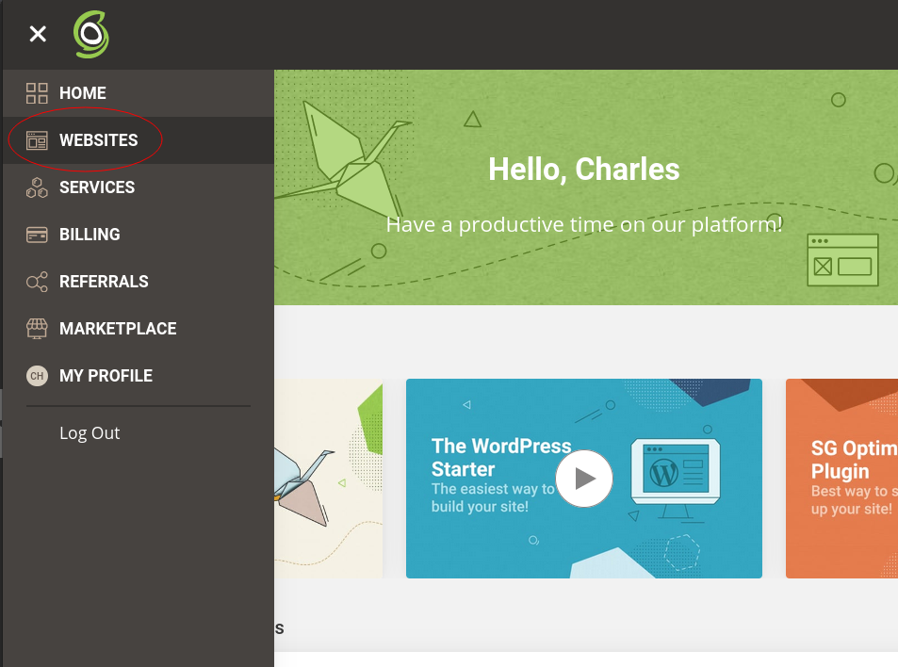

Step 2: Under “Website Details”, you will see your website listed. Click on the button labeled “Site Tools”

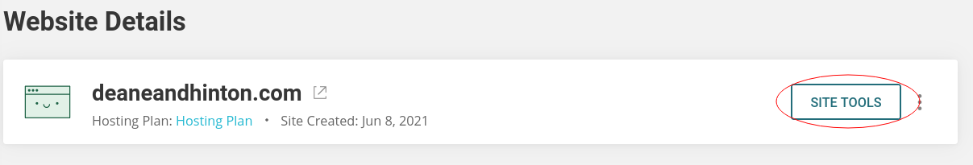

Step 3: Under your pinned tools, you will see a box labeled “Install & Manage Wordpress”. Alternatively, you can find a button labeled the same thing if you open the side menu and go to the subheading “Wordpress”. Click on either of these.

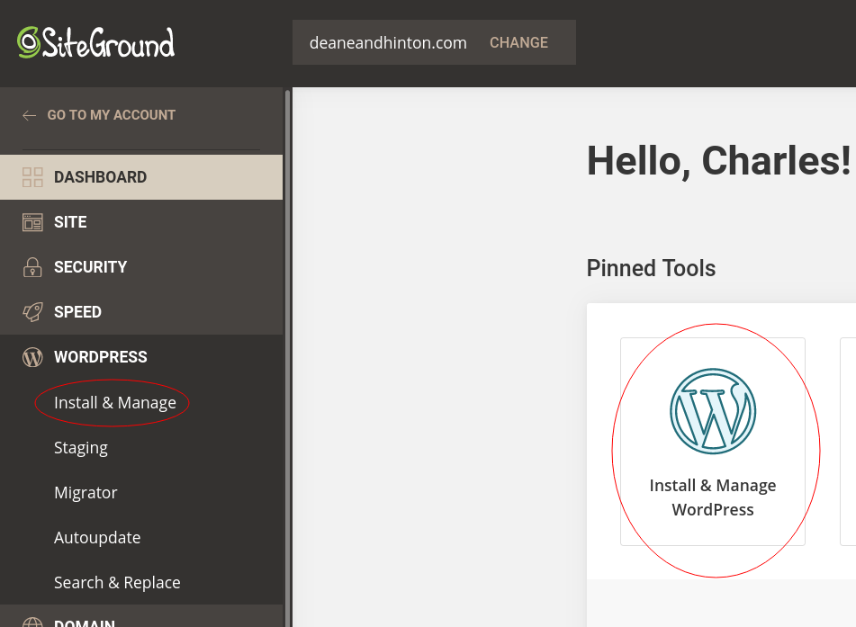

Step 4: At the bottom of your Wordpress management page, you will see a list of your installations. There should only be one, at the domain posts.deaneandhinton.com. Under “Actions” for this installation, click on the icon that looks like a door with an arrow. Doing this should open your Wordpress admin panel. If another tab doesn’t load, then make sure you have popup windows enabled for Siteground.

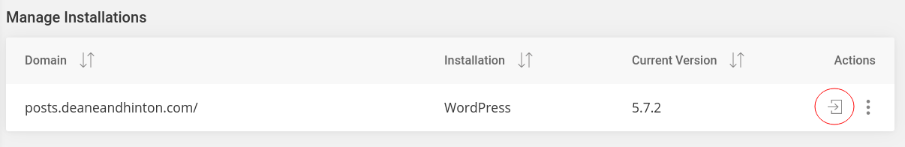

Step 5: All of the content on your website is stored in Posts on Wordpress. To edit this, you will need to go to “Posts”, which will be on the left side of your screen.

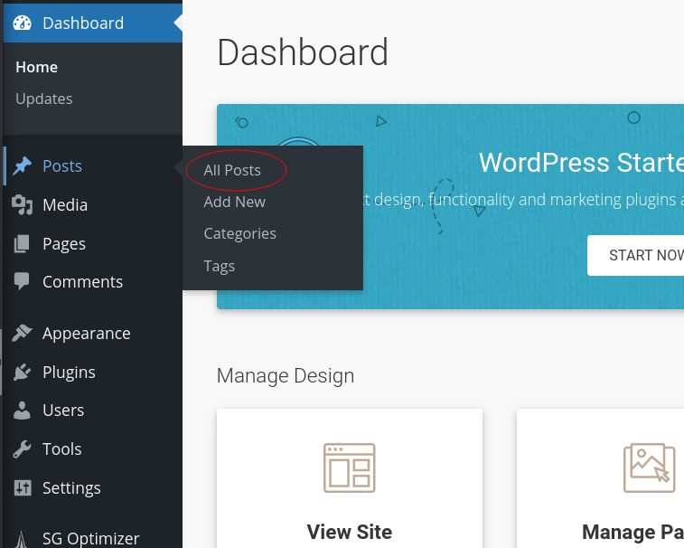

Step 6: You should now be able to see all of your posts. You will notice that your posts have different tags on them. These tags are how you control where the posts are shown on your website. Below I have included three more sections that will walk you through how to use these tags to change what is displayed on your website.

Notification Banner

The top of your website has a dark grey notification banner where you can display temporary messages. These can be an out of office notification, a seasonal message, or a changing of hours. You’re able to change the content of this banner, or deactivate it entirely.

Editing the Message: To edit the message of your notification banner, look for the post that is tagged “notification”. Do not edit the tag of this post. If the tag of this post is anything other than “notification”, spelled correctly and in all lowercase, it will not appear on your website.
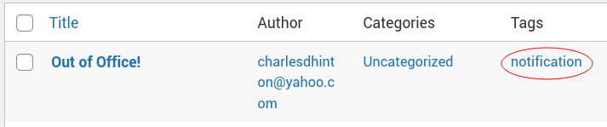
When you have located the correct post, click on “Edit”.
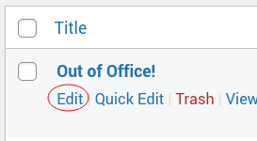

You will then see an editing page. You can change the title and the body of the message. Once you are finished, click on the button that says “Update” in the top right corner of the screen.
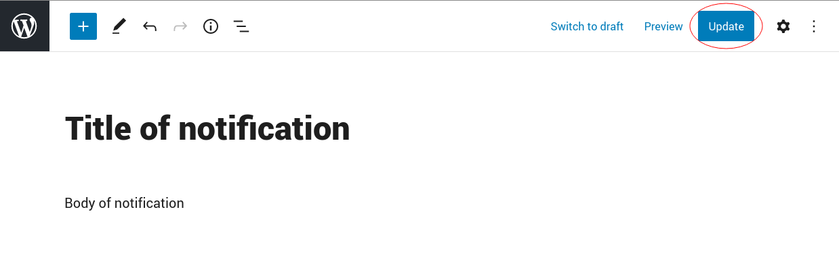
I do not recommend making a new post for notifications. If you want to change the content of your notification banner, edit the existing notification post. If for some reason the existing post is deleted, make a new one with the same tag. Avoid having multiple active posts tagged with notification. If you have a notification post that you will want to reuse, such as an out of office message, but wish to have a different message displaying for the time being, you may deactivate the post that you wish to save.

Activating/Deactivating the Notification: On the posts page, look for the post that is tagged “notification”.
When you have located the correct post, click on “Quick Edit”.
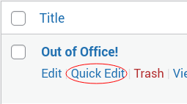

This will pull up a small menu where you can edit certain aspects of the post. Find the field labeled “Status”, and click on the dropdown menu next to it. From here you will be able to choose between the three options “Published”, “Pending Review”, and “Draft”.

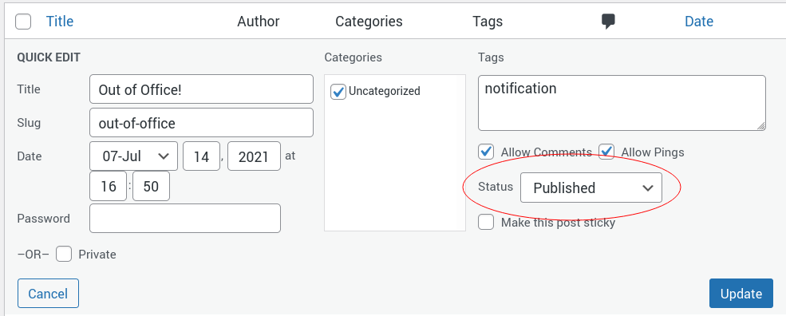
Choosing “Published” will activate the notification banner on your website. Choosing either “Pending Review” or “Draft” will deactivate it. When you have made your selection, click “Update” in the bottom right.

Practice Areas

The main page and practice areas page of your website has several different posts that give an explanation of the main types of legal services that you offer. These are all controlled from your Wordpress panel here, allowing you to change what they say, or how many there are at will. You can have any number of these that you feel you need to accurately convey the kind of work you do, but I would recommend having only the ten most important types.

Editing a Post: To edit an existing post, locate the one you are looking for. All posts representing a legal service will have the tag “ls”. (Lower case LS)
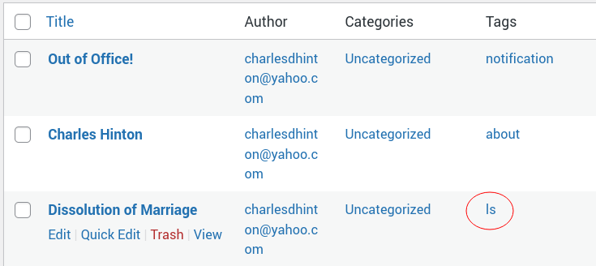
When you have found the post you wish to edit, click on “Edit”.
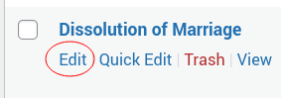

This will bring you to the editing page. Editing the post of a legal service is a slightly more complicated than editing the notification banner. The title and body of the post can be edited in the same way as the notification banner. In addition to this, you can also change what the excerpt that is shown in the card on the home page of your website says. To edit what the excerpt says, locate the gear symbol in the top right corner of the editing page.
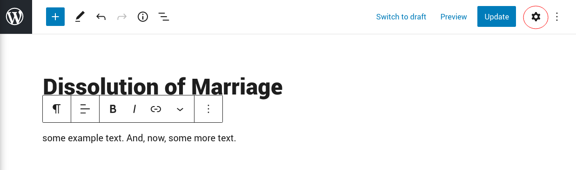
Click on this, and navigate to the “Post” section of the menu that appears. Find the dropdown section that is titled “Excerpt” and click on it.
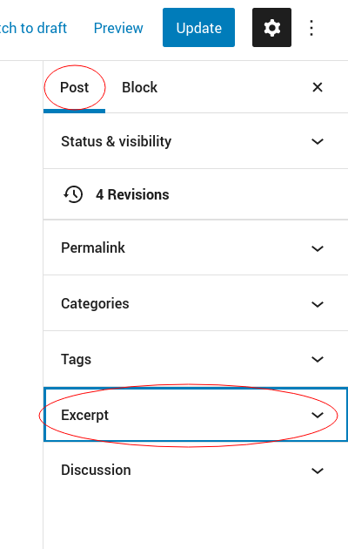

Here, you may write your own summary of the legal service that you are editing. This is optional. If left blank, the excerpt will be automatically generated from the first 50 words of the body of the post. When you are in this advanced editor, be careful not to delete the “ls” tag on the post. If this tag is deleted, then this post will not appear on your website. When you are done, click the “Update” button in the top right corner to save your work.

Adding/Removing a Post: At the time of receiving this manual, there is only one post advertising a legal service that you offer. Since I have recommended having ten legal service posts, you will want to add additional posts. Doing this is quite simple. At the top of the posts page on your Wordpress, you will see a button that says “Add New”. Click on that. Note that, following July 5th, 2022, I do not recommend adding more legal services without talking to me (Alex) first. This is due to the changes made in going from a single practice area page to multiple, each with their own FAQ sections
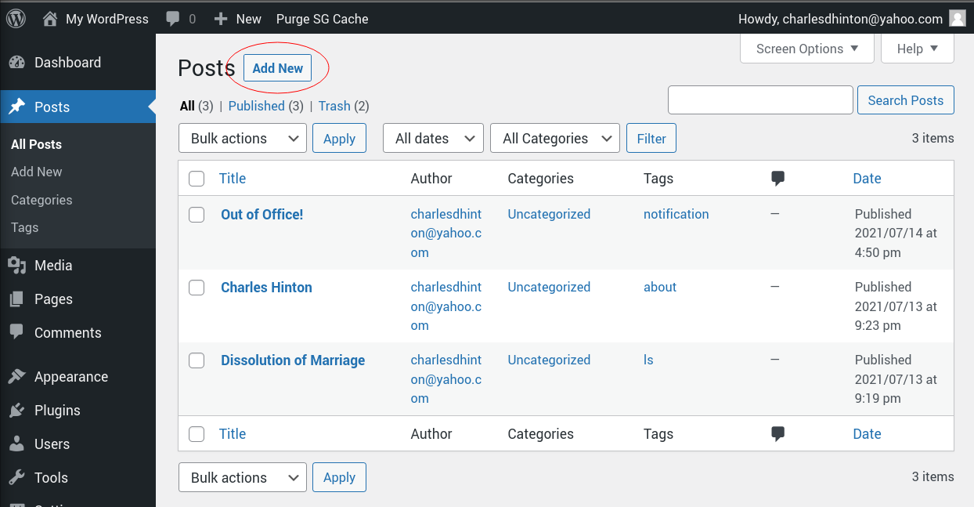
This will bring you to a fresh editing page. There is an area for a title and for a body of the post that you can fill in. If desired, you may add an excerpt to this post. You will find the steps for adding an excerpt in the section for editing a legal service post. However, in order to ensure that your new post appears on your website, you will need to add the correct tag yourself. For legal services, the tag is “ls”, all lowercase and without the surrounding quotation marks. To add it to the post, you will first need to click on the gear icon in the top right corner of the page.
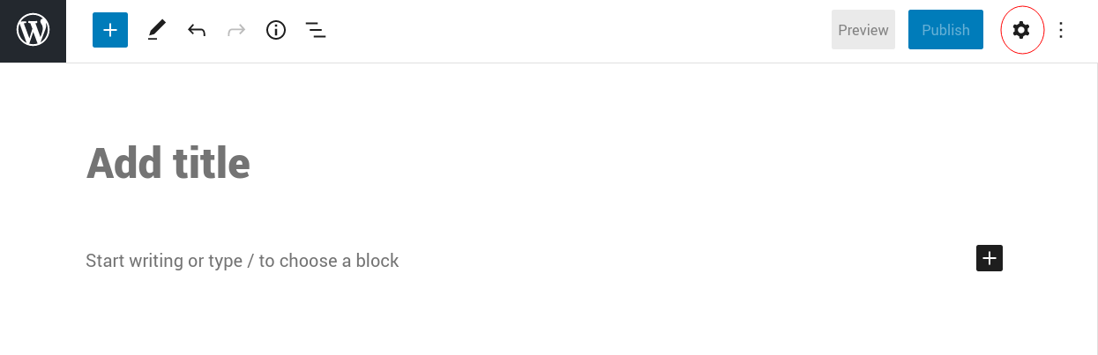
This will bring up an advanced editor. Navigate to the “Post” section of this menu, and then to the “Tags” subheading.
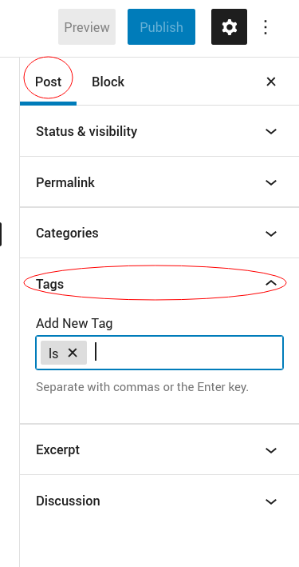

Here, you can enter the tag as shown. Remember to hit enter after you are done, since the tag is not entered properly unless you see the grey box surrounding it. When you are done, then click on “Publish” in the upper right corner of the screen. Once you have clicked on this, the post should save and will appear on your website shortly.

To remove a post from your website, simply locate the post you wish to delete, and click on the red text that says “Trash”.
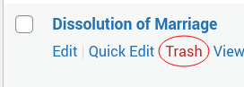

Meet Our Team

The last kind of post you have is the ones that go on you About page. These ones will have not only a description of who you are and what your credentials are, but also a professional picture of you. You will want to be able to edit, create, and delete posts that go in the about section.

Deleting a Post: The tag for this kind of post is “about”, so locate the post you are looking to delete which has the “about” tag.

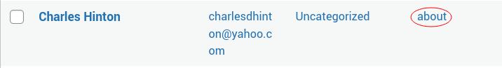
When you have found the post, simply hover over it and click on the red text that says “Trash”.

Editing/Adding a Post: First, find the post that you want to edit, and click on the “Edit” text that appears when you hover over it. Or, click on “New Post”. This is identical to editing other posts. Also the same as other posts, you will be taken to an editor that has a place for a title and a body. However, if you click on the gear icon in the top right corner and navigate to the Post subheading, you will see a section titled “Featured Image”.
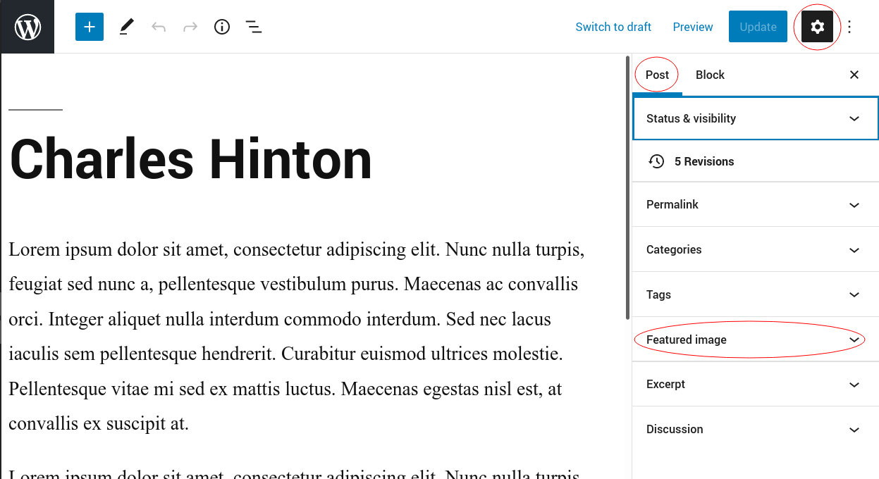
This is where you will be able to change, or add, your profile picture. For proper formatting, please upload a square image. Under the Featured Image tab, you will see your current image (if you have one) with an option to either replace or remove it. If you do not yet have an image, you will see a grey box prompting you to set a featured image.
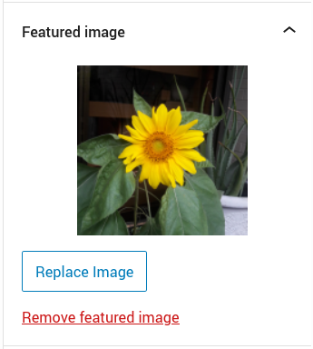
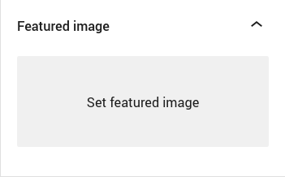

This is how you can change, remove or upload your profile picture. If you are making a new post, remember to add the tag “about”, in all lowercase, to your post. To do this, follow the same instruction as adding the “ls” tag to a legal service post. Remember, if you do not see the grey box around the tag, then it is not properly entered and will not display on your website.
One last thing to remember, is the ordering of these posts. As you add new posts to your website, the most recently created one will always appear at the top of the page. For the Meet Our Team page, make sure to add whichever person’s information you want to show at the top of the page last.

Adding FAQ Posts

Adding a new post for any of the individual practice area pages is simple. Follow the instructions outlined above to make a new post, with the question as the title of the post, and the answer as the post’s body. Before publishing the post, add a tag that matches the page you would like the post to be displayed on. Each of the Legal Services posts are also tagged with the corresponding tag for their individual pages, make sure that the tag you give your FAQ posts match. Wordpress should try to suggest tags based on ones used recently, using those suggestions will ensure you have the correct spelling and capitalization.

